
EXHAUST AFTERTREATMENT SYSTEM - QUICK REFERENCE GUIDE

There are four indicator lights and one gauge related to the aftertreatment system on the instrument cluster | 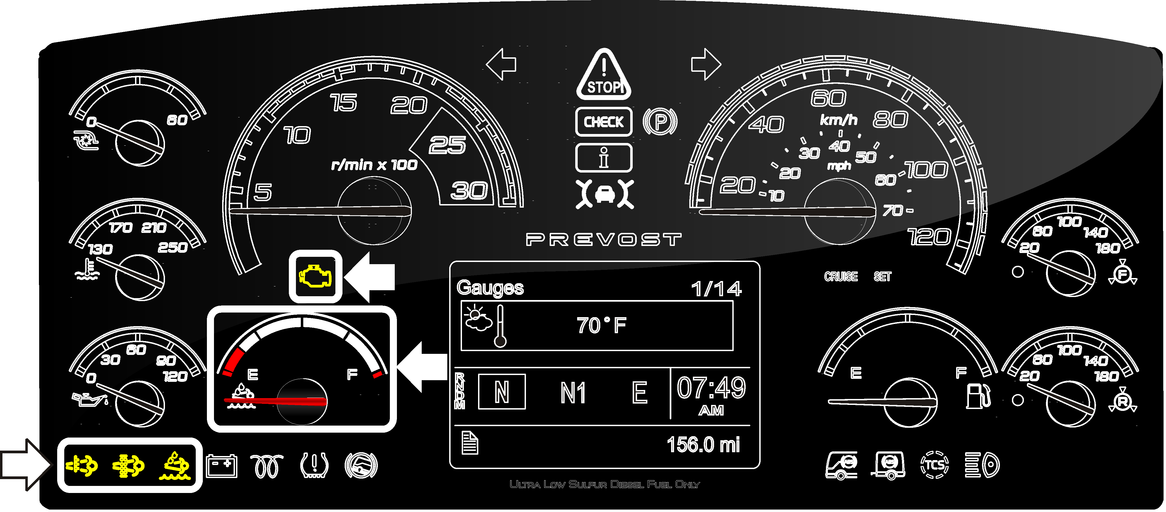

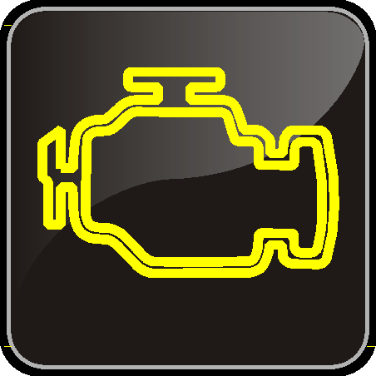 | Aftertreatment system malfunction (malfunction indicator light)
 | Indicates a failure of an emission control device. May illuminates at the same time as the CHECK amber warning light. This light will go out after 3 completed ignition on-ride-ignition off cycles. Vehicle can be driven to end of shift. Call for service.

 | High exhaust system temperature (HEST light)
This indicator light is for your information only. It illuminates to notify the driver of potentially hazardous exhaust gas temperature at the exhaust system diffuser.
Take note that if the vehicle is being driven, this indicator lamp will illuminate for 20 seconds as the temperature at the DPF reaches 977°F (525°C) and then, will turn off.
 | WARNING
During regeneration, exhaust temperature may reach up to 1200°F (650°C) at the particulate filter. When parking the vehicle, if this telltale light is illuminating, make sure that the exhaust system diffuser is away from people or any flammable materials, vapors or structures.

 | DPF regeneration request
 | Illuminates (steady) to notify the driver that a manual regeneration will be required soon. There is no urgency as long as this indicator light doesn’t blink.

 | Low DEF level
Illuminates when there is less than 2.6 gallons (10 liters) of DEF left in the tank.
This indicator light starts flashing when there is only 0.6 gallons (2.5 liters) left in the tank. If the vehicle is kept in operation with an empty DEF tank, and engine derate will eventually occur, followed by a 5 mph speed limitation.

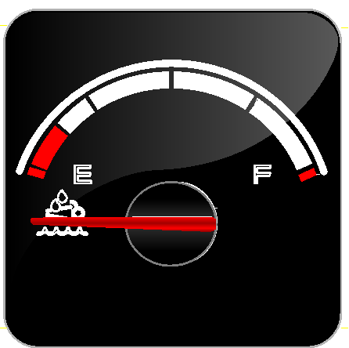 | DEF level gauge
 | Indicates the amount of DEF (Diesel Exhaust Fluid) remaining in the DEF tank. The DEF tank is considered as being full when it contains 16 gallons (60 liters) of DEF. DEF consumption will be approximately 2% of the diesel fuel consumed.

Initiating stationary (parked) regeneration
The DPF Regeneration REQUEST indicator light illuminates to notify the driver that a manual (stationary) regeneration will be required soon.

DPF REGENERATION indicator light

If stationary regeneration is not performed, this telltale light will eventually blink, indicating that a stationary regeneration is required immediately. If stationary regeneration is still not performed, “engine power derate and shutdown” sequence may occur as per level 1 to level 4 sequence.

To initiate a stationary regeneration:
- Park the vehicle in a clear area, vehicle speed must be 0 mph (0 km/h);
- Engine must be on normal idle and fully warmed up (coolant temperature above 140°F/60°C);
- Apply parking brake and set the transmission to neutral (N).
- Press ENTER or ESCAPE button on the steering wheel and then get to the Driver Information Display AFTERTREATMENT menu. Using the UP/DOWN button on the steering wheel, select sub-menu REQUEST PARKED REGEN and press ENTER button to confirm and initiate regeneration.
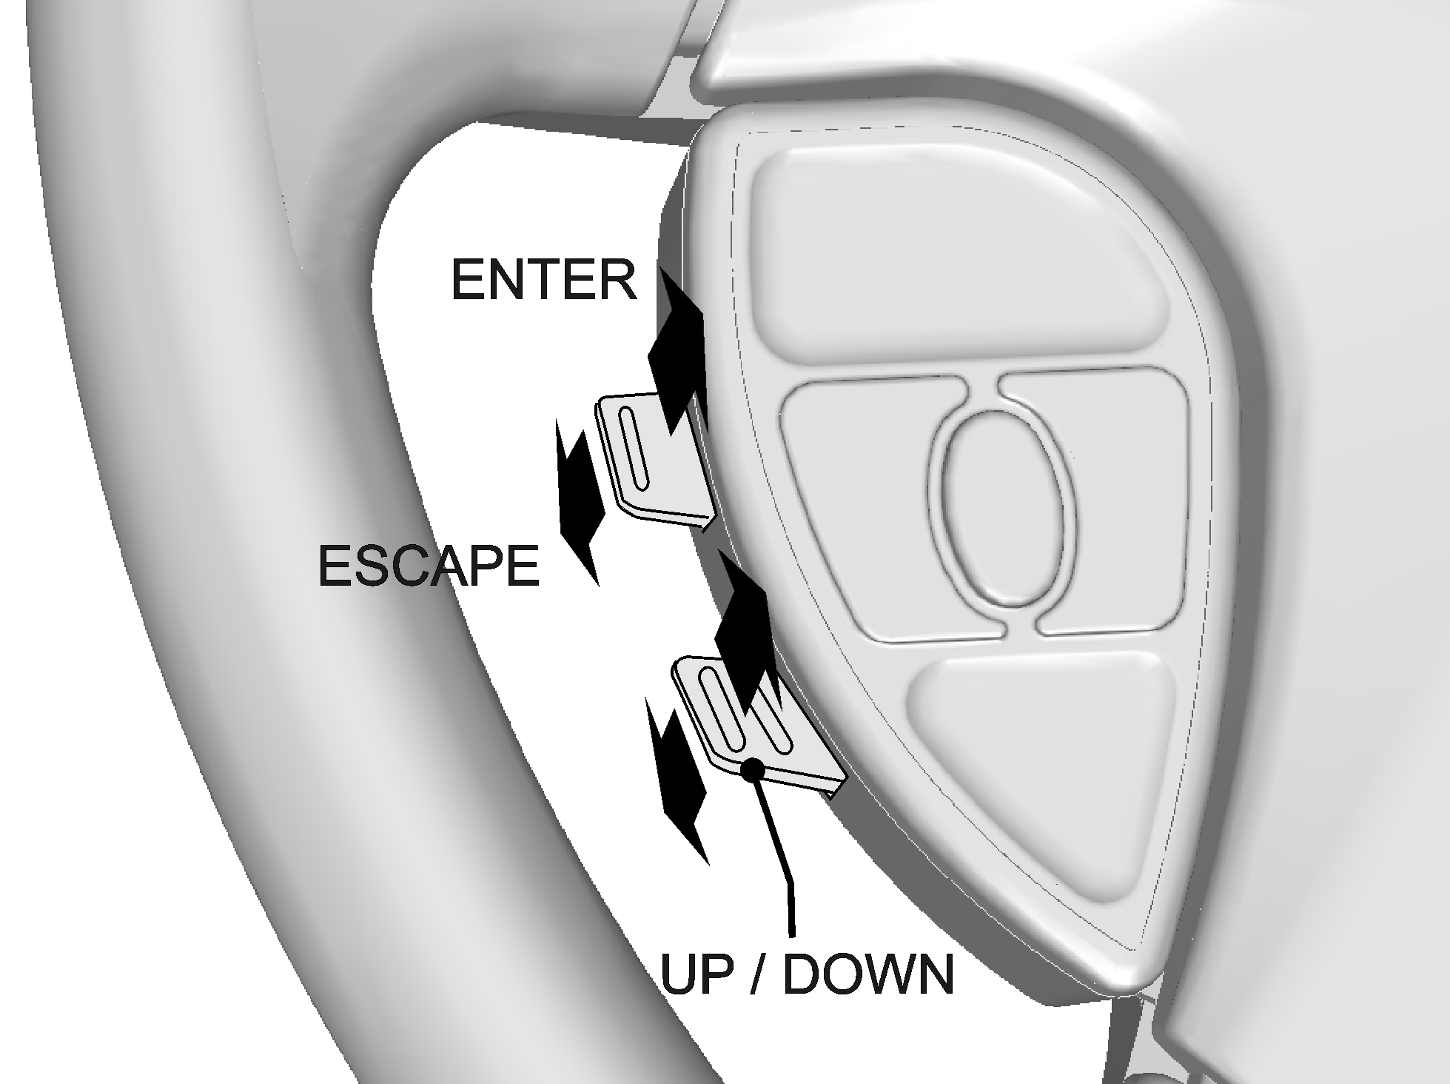

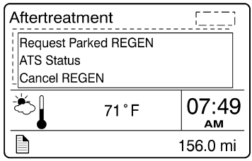

The regeneration will begin. Turn off the air conditioning to reduce engine load. The engine idling speed will increase to 1600 rpm. Once the regeneration is completed, the engine speed will return to normal idle.

Voluntary interruption of a stationary regeneration
It is possible to interrupt a stationary regeneration at all time. To do so, set the ignition key to the OFF position or get to the Driver Information Display AFTERTREATMENT menu, select Cancel REGEN and press ENTER button to confirm. You can stop regeneration simply by releasing the parking brake. Use this procedure in order to move the vehicle in a safe area.
If regeneration is interrupted, it is very important to reinitiate the regeneration as soon as possible.

Diesel particulate filter clogging sequence
LEVEL 1   solid | REGENERATION NEEDED  Diesel particulate filter is becoming full  The DPF Regeneration indicator light illuminates to notify the driver that a stationary regeneration (parked) will be required soon. When this light is lit, initiate stationary regeneration process at an appropriate time of day. THERE IS NO URGENCY AT THIS LEVEL.
LEVEL 2  blinking | REGENERATION REQUIRED  Diesel particulate filter full  If no DPF regeneration occurs after the initial DPF Regeneration indicator light illumination, the light will start blinking and a stationary regeneration should be initiated as soon as possible in order to prevent from entering into Level 3.
LEVEL 3  blinking  +   | ATD SERVICE REQUIRED  ENGINE DERATE ACTIVE  Diesel particulate filter overfull  If the blinking DPF Regeneration indicator light is still ignored, the CHECK amber warning light will illuminate. In that situation, engine performance is limited. Perform a parked regeneration IMMEDIATELY to avoid further engine derate and prevent from entering into Level 4.
LEVEL 4  blinking  +  +   | ATD SERVICE REQUIRED  ENGINE SHUTDOWN ACTIVE  A serious engine problem has occurred. The DPF may be over its maximum capacity.  If a stationary regeneration is still not initiated, a standard Engine Protection Shutdown sequence will occur. All of the following dashboard lamps will be present:  Blinking DPF Regeneration indicator light;  Solid CHECK amber warning light;  Solid STOP warning light.  Once engine derate and/or shutdown sequence is completed, a stationary regeneration must occur to continue vehicle operation. If the driver continues to operate the vehicle without regeneration, additional measures will be taken to protect the engine and ATD from damage, up to and including engine shutdown. Parked regeneration might no longer be possible.

The exhaust aftertreatment system consists of two units, the filtration and regeneration unit and the selective catalytic reduction (SCR) unit.

Selective catalytic reduction unit
Selective Catalytic Reduction (SCR) is a technology that uses Diesel Exhaust Fluid (DEF) and a catalytic converter to reduce nitrogen oxides (NOx) emissions.
SCR is an exhaust aftertreatment system that injects small amount of DEF into the exhaust gas between the DPF and the selective reduction catalytic converter. DEF turns to ammonia and carbon dioxide when heated. The exhaust stream then passes over a catalyst, the ammonia reacts with the NOx to form nitrogen and water vapor.
The basic elements of the SCR system consist of a 15.9 gallons (60 liters) DEF tank complete with pump, lines and heating system, a dosing injector, a catalytic converter and the control and monitoring system. DEF consumption is related to fuel consumption. In order to meet EPA2010 requirements, DEF tanks are sized so one refill will be necessary every two refill of the fuel tank.

Filtration and regeneration unit
The main purpose of the filtration and regeneration unit is to capture and oxidize (regenerate) the particulate matter (soot) in the engine exhaust gas. The exhaust gas first enters the Diesel Oxidation Catalyst (DOC) and then flow through the Diesel Particulate Filter (DPF); together they capture and regenerate the soot on a regular or passive basis. Through constant monitoring of the exhaust gas temperature and the system back pressure, the engine control module is able to manage regeneration.

Passive regeneration
Passive regeneration is the process by which the particulate matter is oxidized due to the heat generated by the engine internal combustion process. During normal highway operation, exhaust temperatures alone are usually high enough to oxidize accumulating soot. In low ambient temperatures, however, or in some stop-and-go applications, the system needs a little help to regenerate, or clean itself. This process is called “active” regeneration.

Active regeneration
Active regeneration is necessary when the engine internal combustion process alone does not generate enough heat. A dosing system injects a mist of diesel fuel into the exhaust system to increase and maintain the aftertreatment system temperature. Exhaust temperature must be above 572°F (300°C) to initiate the oxidation catalyst, which in turn oxidizes the injected diesel fuel molecules to achieve up to 1200°F (650°C) exhaust temperature at the particulate filter. This process of active regeneration takes place during the normal operation cycle of the vehicle without charges in performance or control for the operator. EPA2010 compliant Volvo engines produce less soot, so less active or stationary regeneration will be required.

Stationary (parked) regeneration
In a small number of specific engine duty cycles, engine control module may not be capable of completing an active regeneration. In these situations, the operator will be notified that a stationary or parked regeneration may be required. A DPF telltale light will illuminate indicating the need for user interaction. The lamp gives the operator a grace period to allow this process to take place at a time when most convenient for the operator. This process requires the vehicle to be parked while a driver or maintenance technician initiates the regeneration process using the DID menus. Once initiated, the stationary regeneration process will be complete in about 45 minutes.
The driver will be notified of the need for a stationary regeneration (parked) by illumination of the DPF Regeneration telltale light.
NOTE
At starting of the engine, if a stationary regeneration is required, the engine coolant temperature must reach 140°F (60°C) before any stationary regeneration may be initiated and completed. Permit the engine to idle for a short while or drive the vehicle until engine temperature increases sufficiently.

 | WARNING
Do not initiate a stationary regeneration in a closed area like a garage. Stationary regenerations must be undertaken outdoors only.

 | WARNING
During stationary regeneration, exhaust temperature may reach up to 1200°F (650°C) at the particulate filter. Before initiating stationary regeneration, make sure that the DPF outlet diffuser is clear of objects and that no one is working near the DPF outlet diffuser.
Hot surfaces. Keep yourself clear of all hot Aftertreatment Device components, particularly during and after active or stationary regeneration. Hot surfaces can cause serious burns.
Diesel particulate filter cleaning
Besides trapping soot, the also traps the ash that has been generated when additives in engine oil are burned. However, unlike soot, ash cannot be oxidized. The ash that accumulates in the filter will eventually cause an increase in exhaust back pressure. The ECM will constantly monitor the ash accumulation and forecast the approximate time until DPF ash cleaning is required. This information is stored in the ECM. This allows you the opportunity to plan for the DPF ash cleaning interval. If ash cleaning is not performed proactively, and the back pressure increases beyond the system limit, the ECM will flag the amber warning light on the telltale panel, notifying the operator an ash cleaning is required. Clean remanufactured DPF cartridge will be available on an exchange basis. For most vehicle applications and duty cycle, this will occur after approximately 250,000 miles (400,000 km) of operation.

